Millennium Development Goal 2: Achieve Universal Primary Education
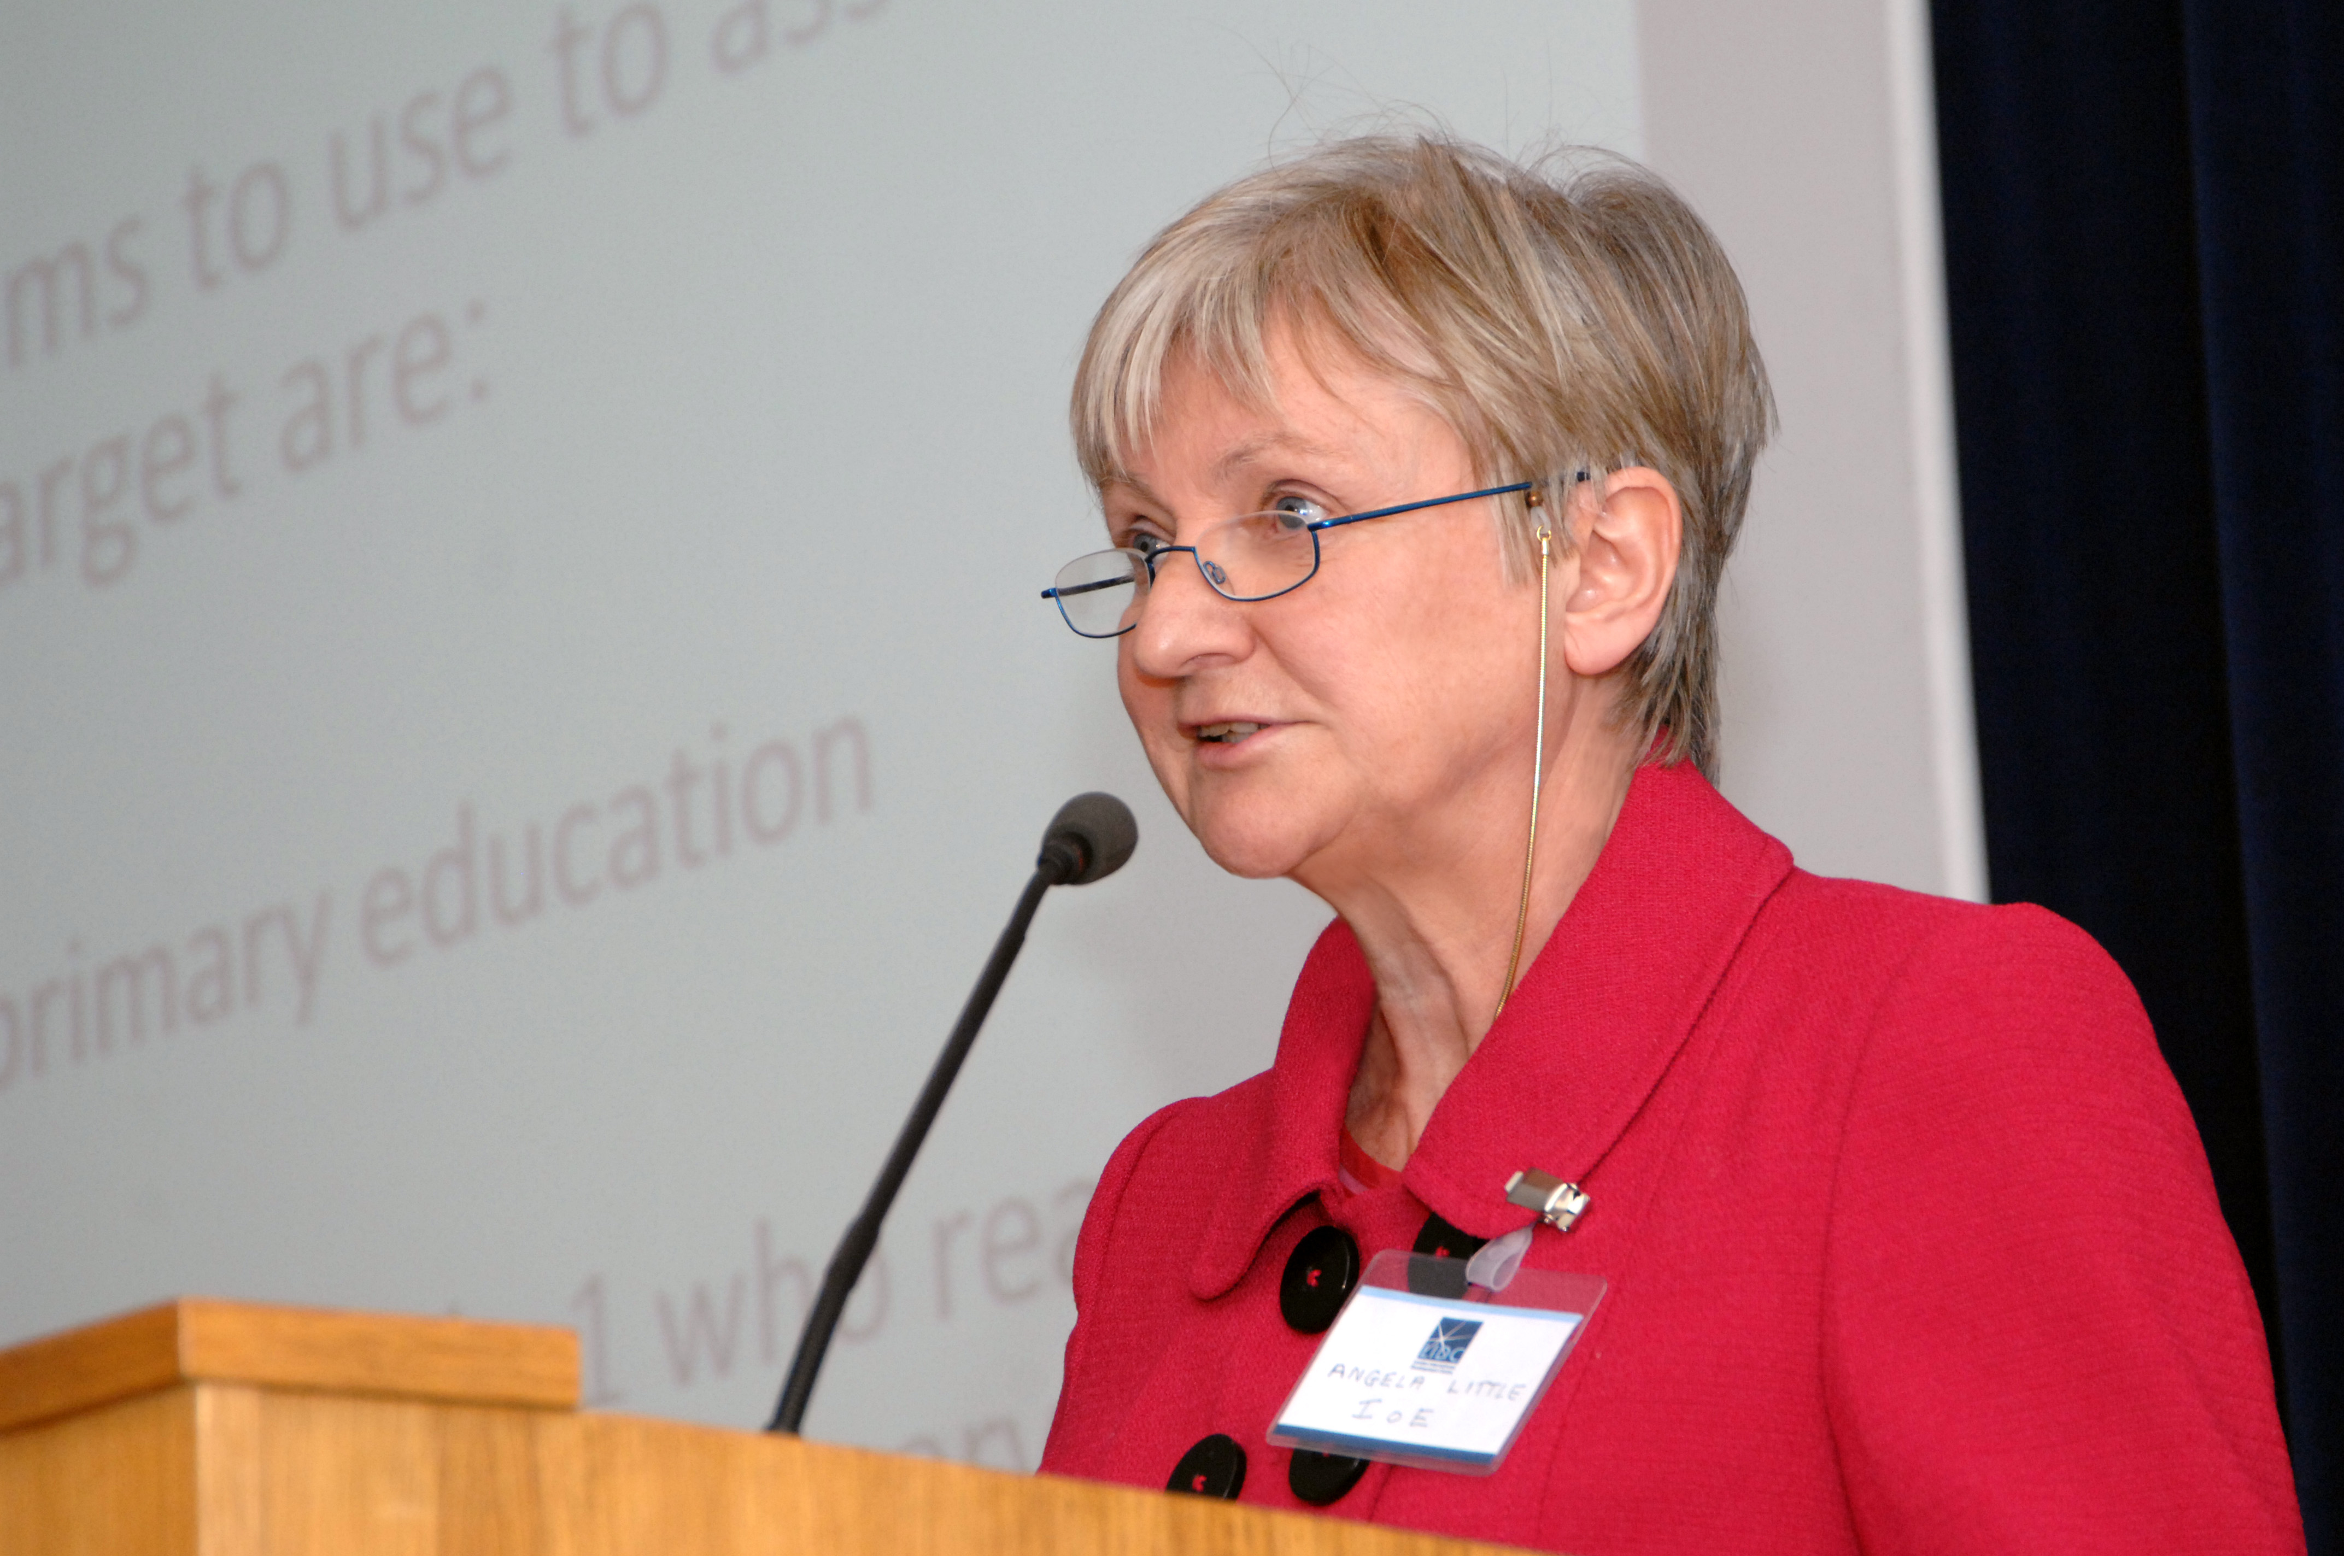
Professor Angela Little. Credit: Anne Koerber.
Professor Angela Little, of the Institute of Education (IoE), showed at LIDC’s conference on 5 November how MDG2’s aim of universal primary education overlooks the complexity of improving education. She highlighted the challenges within the education sector and described MDG2 as having “limited vision”, partly because it neglects secondary and tertiary education. Little also spoke of the strong connections between MDG2 and the other MDGs, including those concerned with poverty, female empowerment, water and sanitation.
Rising school enrolment
Little initially mentioned encouraging rising school enrolment figures during the conference called No Goals at Half-time: What Next for the MDGs? Progress is being made towards MDG2’s target to ensure that, by 2015, children everywhere will be able to complete a full course of primary schooling. For example, the Net Enrolment Rate (NER) in primary education (number of pupils of primary school age enrolled either in primary or secondary education) has increased in all developing countries from 80 per cent in 1991 to 88 per cent in 2006. She illustrated how this was a marked improvement on the situation in the early 20th century. According to trends observed between 1911 and 1934 in the Gold Coast (present day Ghana) it was estimated that it would take 600 years to achieve full school enrolment; in 2005 the NER figure for Ghana was about 70 per cent.
However, she showed the limitations of NERs as they do not reveal patterns of enrolment. Often there is a surge in enrolment in Grade One with overage children and they often do not continue their schooling to Grade Six. There are also marked differences between enrolment rates for different groups based on income and gender, and these discrepancies, such as those between rich boys and poor girls, are not clear from the NERs. Achieving MDG2’s enrolment target may involve crowded classrooms, untrained teachers and lack of teaching materials, in which case, learning is not achieved. Little argued that there is an “enormous gap” between enrolment and learning.
Challenges facing education
Little emphasised the problem of teacher shortages as the supply of teachers has not kept pace with the growth in enrolment. According to UNESCO 18 million new primary teachers will be needed by 2015. Moreover, at least 30 per cent of teachers in primary schools in developing countries teach more than one grade at the same time, unsupported by curriculum materials and training.
Little referred to the notion, expressed by UN Secretary-General Ban Ki-Moon, that primary education is an irreversible gain, and warned that skills can atrophy if they are not used in school or the workplace. She asked whether primary education was being wrongly seen as a “vaccine” and challenged the “policy myopia” of focusing on primary education at the expense of secondary and tertiary education. Little pointed out how such an approach overlooks the need for skilled workers in many sectors, including education, health and agriculture. She said the value of primary education may well decline if economies do not expand fast enough to accommodate school leavers. Little added: “The qualification goalposts for access to work will shift. And picking up the theme of the conference, there may not only be no goal at half-time, but by the time the fullbacks, midfielders and strikers get their act together, the very goalposts at which the ball is targeted may well have shifted”.
Importance of cross-sectoral approach
Little highlighted the need for an integrated approach to the MDGs because of their reciprocal connections with each other. She showed how poverty restricts investment in education and is associated with malnutrition, which, in turn, reduces educational attainment. Also, lack of access to sanitation and clean water at school and at home lead to health problems. Little acknowledged the difficulties of undertaking an integrated strategy, but urged such an approach which recognises the synergies and long-term benefits of addressing the MDGs in a coordinated way. She said: “We need to keep on underlining the interrelations between all the MDGs”.
Professor Angela Little is the chair of the Education and International Development Department at IoE. Her current research interests include the analysis of progress towards Education for All in developing countries, the impact of economic liberalisation policies on qualifications and education and learning and teaching in multi-grade settings. She leads the IOE’s programme within the Consortium for Research on Educational Access, Transitions and Equity (CREATE) in Bangladesh, Ghana, India and South Africa.

